**Laboratory Works for TOC**

**LAB 1 : Write a program to find prefixes, suffixes and substring from given string.**

Code:

/* To find substring, prefix, suffix of a string */

#include<stdio.h>

#include<string.h>

void find_prefix(char string[]);

void find_suffix(char string[]);

void find_substring(char string[],int,int);

int main()

{

char string[20];

int i,j;

printf("\n Enter a string\t");

gets(string);

printf("\n Prefixes:");

find_prefix(string);

printf("\n Suffixes");

find_suffix(string);

printf("\nEnter i and j for substring");

scanf("%d%d",&i,&j);

find_substring(string,i,j);

return 0;

}

void find_prefix(char string[])

{

int i,j;

char prefix[20];

for(i=strlen(string);i>=0;i--)

{

for( j = 0; j<i;j++)

{

prefix[j]= string[j];

}

prefix[j]='\0';

printf("\n %s",prefix);

}

}

void find_suffix(char string[])

{

int i,j,k;

char suffix[20];

for(i=0;i<=strlen(string);i++)

{

k = i;

for( j = 0; j<strlen(string);j++)

{

suffix[j]= string[k];

k++;

}

suffix[j]='\0';

printf("\n %s",suffix);

}

}

void find_substring(char string[],int x, int y)

{

char substr[20];

int k=0;

for(int i=x-1;i<y;i++)

{

substr[k]=string[i];

k++;

}

substr[k]='\0';

printf("\n Substring:\n%s",substr);

}

**OUTPUT:**

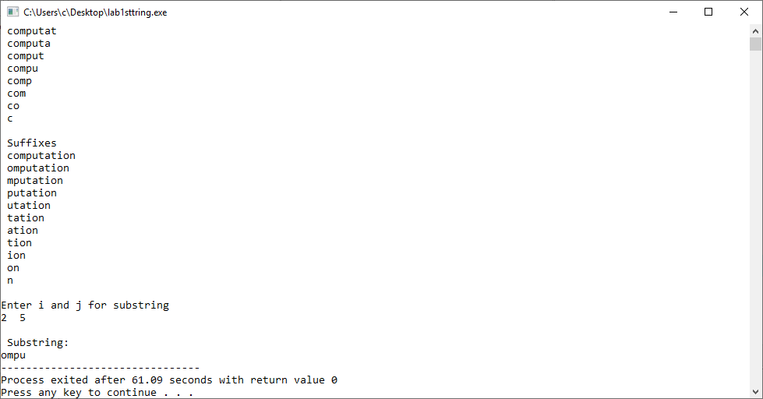

**LAB 2: Write program to implement following DFA's over alphabet $Σ=\{0,1\}$.**

1. The DFA that accepts all the strings that start with 01.

0, 1

1

0

0

1

0, 1

**Code**

/* Implement a DFA for L = { set of all strings over {0,1} such that string start with 01 */

#include<stdio.h>

enum states { q0, q1, qf,qd};

enum states delta(enum states, char);

int main()

{

char input[20];

enum states curr_state = q0;

int i =0;

printf("\n Enter a binary string\t");

gets(input);

char ch = input[i];

while( ch !='\0')

{

curr_state = delta(curr_state,ch);

ch = input[++i];

}

if(curr_state == qf)

printf("\n The string %s is accepted.",input);

else

printf("\n The string %s is not accepted.",input);

return 0;

}

// Transition Function

enum states delta(enum states s, char ch)

{

enum states curr_state;

switch(s)

{

case q0:

if(ch=='0')

curr_state = q1;

else

curr_state = qd;

break;

case q1:

if(ch=='1')

curr_state = qf;

else

curr_state = qd;

break;

case qf:

if(ch=='0')

curr_state = qf;

else

curr_state = qf;

break;

case qd:

if(ch=='0')

curr_state = qd;

else

curr_state = qd;

break;

}

return curr_state;

}

**OUTPUT:**

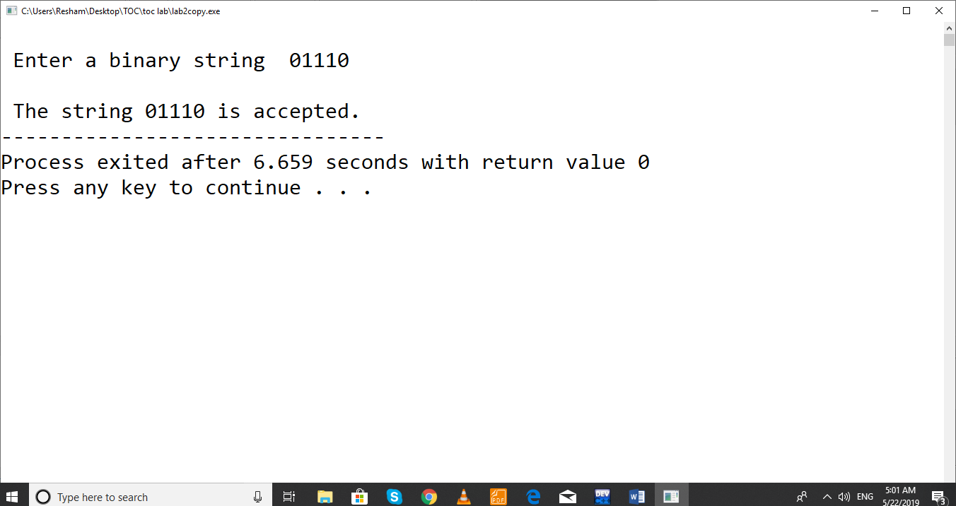

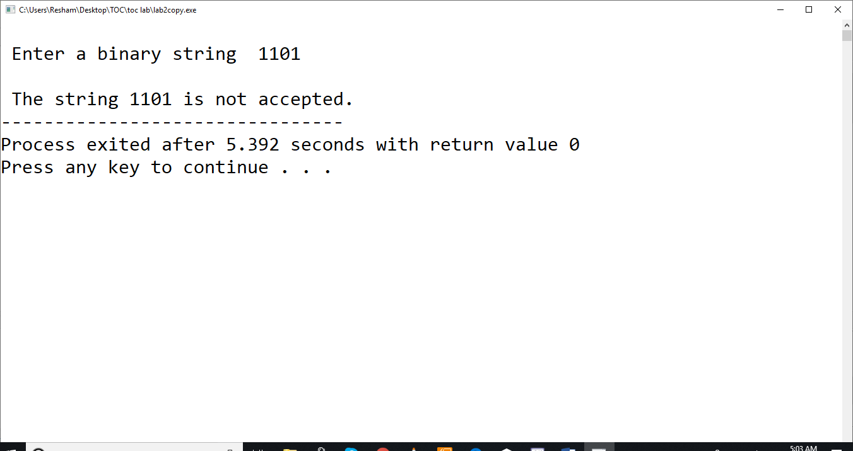

1. The DFA that accepts all the strings that end with 01.

Q = { q0, q1, qf}

start state = q0,

Final state = qf

Transition function, $δ$ is defined as:

$$δ \left(q0, 0\right)=q1$$

$$δ \left(q0, 1\right)=q0$$

$$δ \left(q1, 0\right)=q1$$

$$δ \left(q1, 1\right)=qf$$

$$δ \left(qf, 0\right)=q1$$

$$δ \left(qf, 1\right)=q0$$

**Code:**

// Implement a DFA for L = { set of all strings over {0,1} such that string end with 01

#include<stdio.h>

enum states { q0, q1, qf};

enum states delta(enum states, char);

int main()

{

char input[20];

enum states curr_state = q0;

int i =0;

printf("\n Enter a binary string\t");

gets(input);

char ch = input[i];

while( ch !='\0')

{

curr_state = delta(curr_state,ch);

ch = input[++i];

}

if(curr_state == qf)

printf("\n The string %s is accepted.",input);

else

printf("\n The string %s is not accepted.",input);

return 0;

}

enum states delta(enum states s, char ch)

{

enum states curr_state;

switch(s)

{

case q0:

if(ch=='0')

curr_state = q1;

else

curr_state = q0;

break;

case q1:

if(ch=='1')

curr_state = qf;

else

curr_state = q1;

break;

case qf:

if(ch=='0')

curr_state = q1;

else

curr_state = q0;

break;

}

return curr_state;

}

**OUTPUT:**

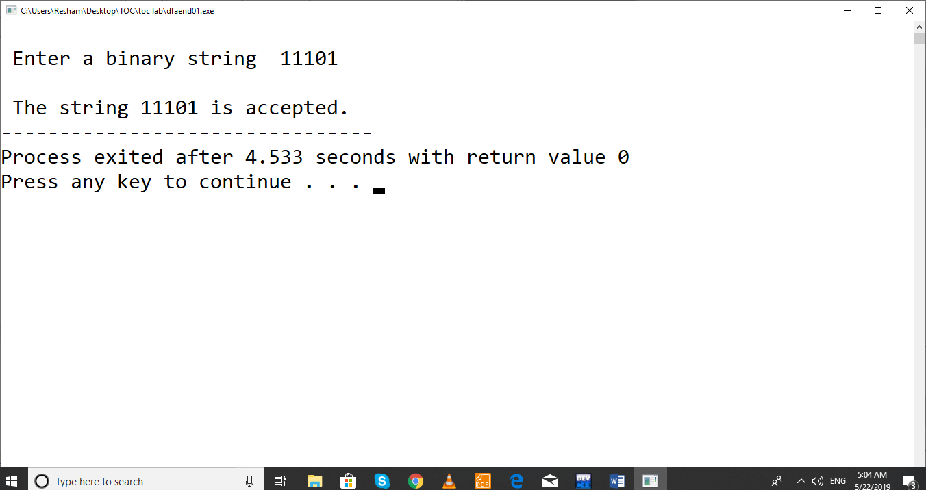

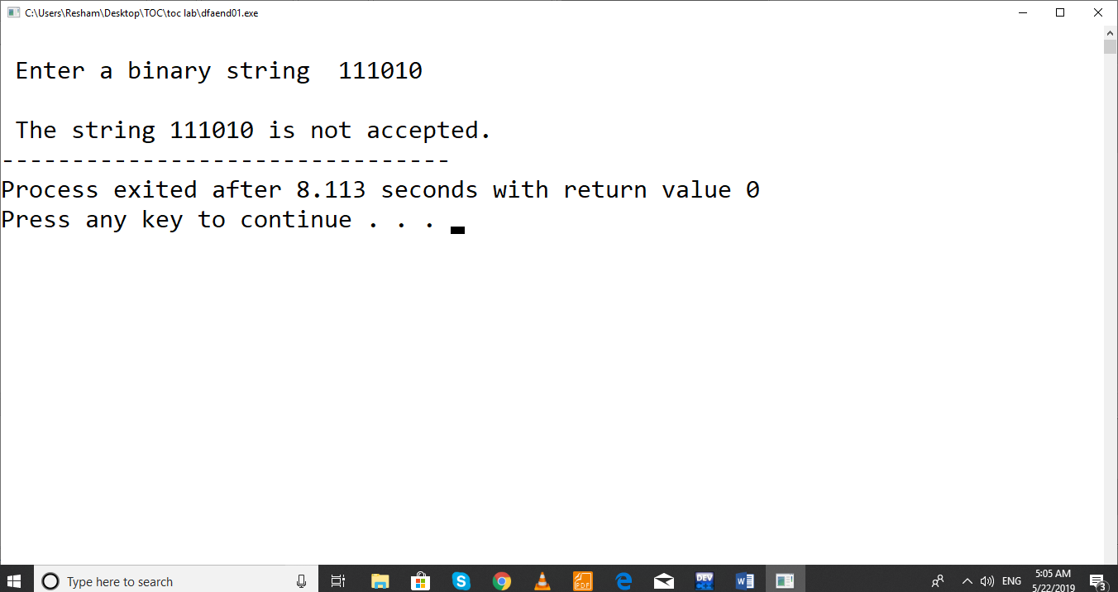

1. The DFA that accepts all the string that contains substring 001.

Q = { q0, q1, q2, qf}

start state = q0,

Final state = qf

Transition function, $δ$ is defined as:

$$δ \left(q0, 0\right)=q1$$

$$δ \left(q0, 1\right)=q0$$

$$δ \left(q1, 0\right)=q2$$

$$δ \left(q1, 1\right)=q0$$

$$δ \left(q2, 0\right)=q2$$

$$δ \left(q2, 1\right)=qf$$

$$δ \left(qf, 0\right)=qf$$

$$δ \left(qf, 1\right)=qf$$

**Code:**

// Implement DFA that accepts strings with sub string 001 over {0,1}

#include<stdio.h>

enum states { q0,q1,q2,qf};

enum states delta(enum states, char);

int main()

{

enum states curr_state = q0;

char string[20], ch;

int i=0;

printf("\n Enter a string \t");

gets(string);

ch = string[i];

while(ch!='\0')

{

curr_state = delta(curr_state,ch);

ch = string[++i];

}

if(curr_state==qf)

printf("\n The string %s is valid.",string);

else

printf("\n The string %s is not valid.",string);

return 0;

}

enum states delta(enum states s, char ch)

{

enum states curr_state;

switch(s)

{

case q0:

if(ch=='0')

curr_state = q1;

else

curr_state = q0;

break;

case q1:

if(ch=='0')

curr_state = q2;

else

curr_state = q0;

break;

case q2:

if(ch=='0')

curr_state = q2;

else

curr_state = qf;

break;

case qf:

if(ch=='0'||ch=='1')

curr_state = qf;

}

return curr_state;

}

**OUTPUT**

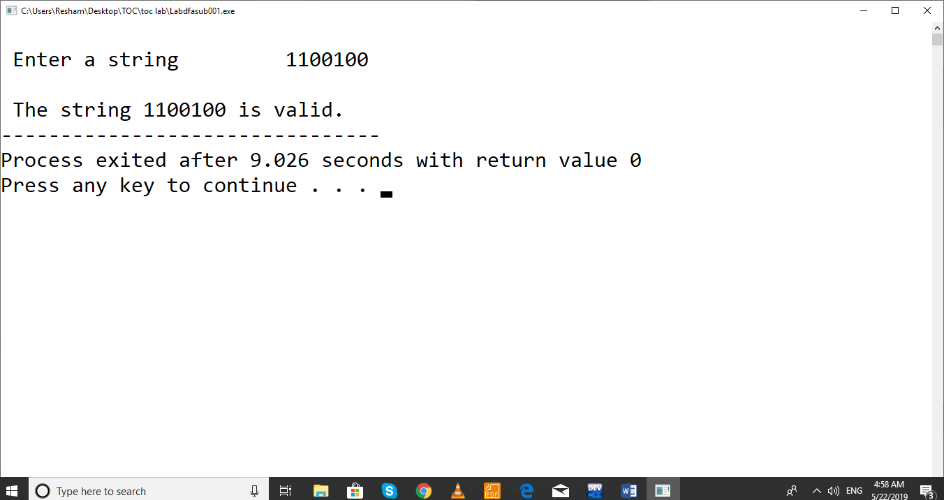

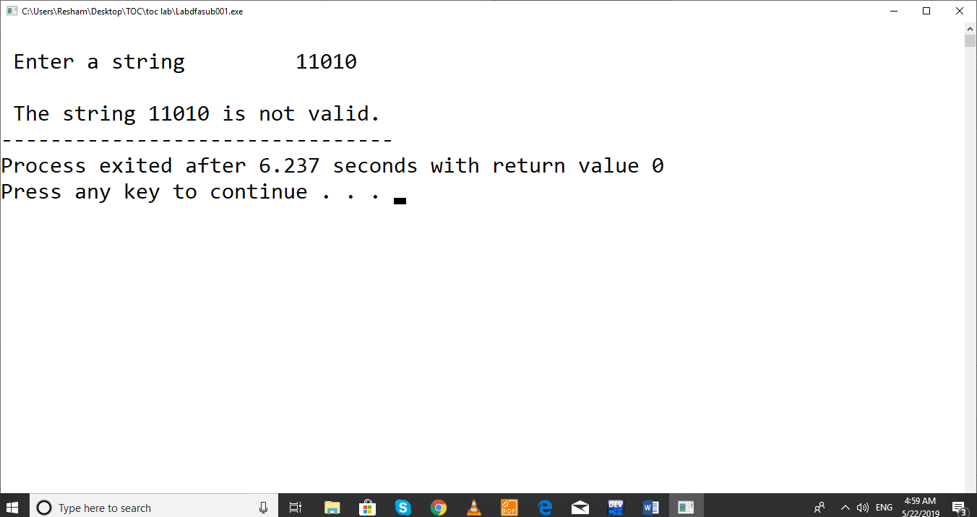

**LAB 3: Write a program to validate C identifiers and keywords.**

**C identifiers:** These are the names of variables, functions, arrays, structures and pointers etc. The first character of C identifiers must be letter or underscore and remaining characters might be letters, digits or underscore.

**Keywords:** These are the reserved words having predefined meaning in the language. There are 32 keywords in C. They cannot be used as identifiers.

***code:***

// to identify valid identifiers and keywords in C

#include<stdio.h>

#include<string.h>

char keyword[32][10]= { "auto","double","int","struct","break","else","long", switch","case", "enum", "register", "typedef","char", "extern", "return", "union", "const", "float", "short", "unsigned","continue","for","signed","void","default", "goto", "sizeof", "volatile", "do","if","static","while"} ;

enum states { q0, qf, qd};

enum states delta(enum states, char);

int iskeyword(char []);

int main()

{

enum states curr_state = q0;

char string[20], ch;

int i=0;

printf("\n Enter a string \t");

gets(string);

ch = string[i];

if(iskeyword(string))

printf("\n The string %s is keyword.",string);

else

{

while(ch!='\0')

{

curr_state = delta(curr_state,ch);

ch = string[++i];

}

if(curr_state==qf)

printf("\n The string %s is valid indentifier.",string);

else

printf("\n The string %s is neither keyword nor valid identifier.",string);

}

return 0;

} //end of the main

//transition function

enum states delta(enum states s, char ch)

{

enum states curr_state;

switch(s)

{

case q0:

if(ch>='A' && ch<='Z'||ch>='a'&&ch<='z'||ch=='_')

curr_state = qf;

else

curr_state = qd;

break;

case qf:

if(ch>='A' && ch<='Z'||ch>='a'&&ch<='z'||ch=='_'||ch>='0'&&ch<='9')

curr_state = qf;

else

curr_state = qd;

break;

case qd:

curr_state = qd;

}

return curr_state;

}

int iskeyword(char str[])

{

for(int i=0;i<32;i++)

{

if(strcmp(str,keyword[i])==0)

return 1;

}

return 0;

}

**OUTPUT**

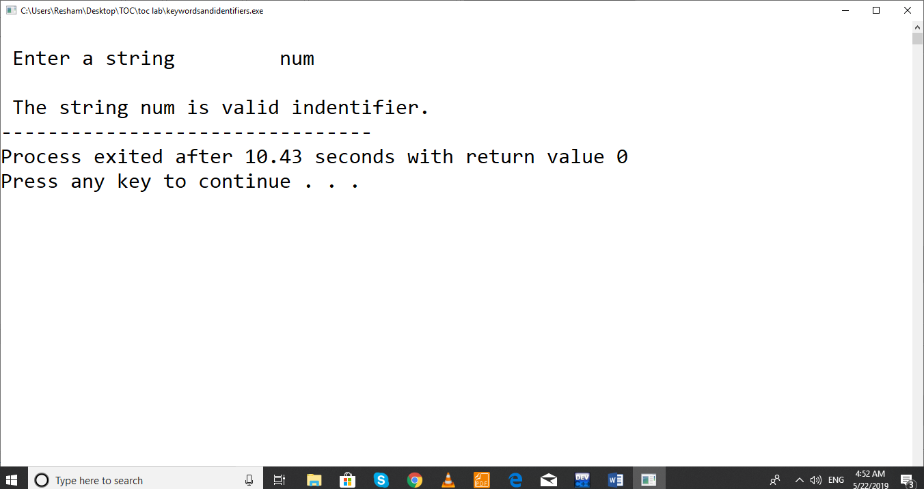

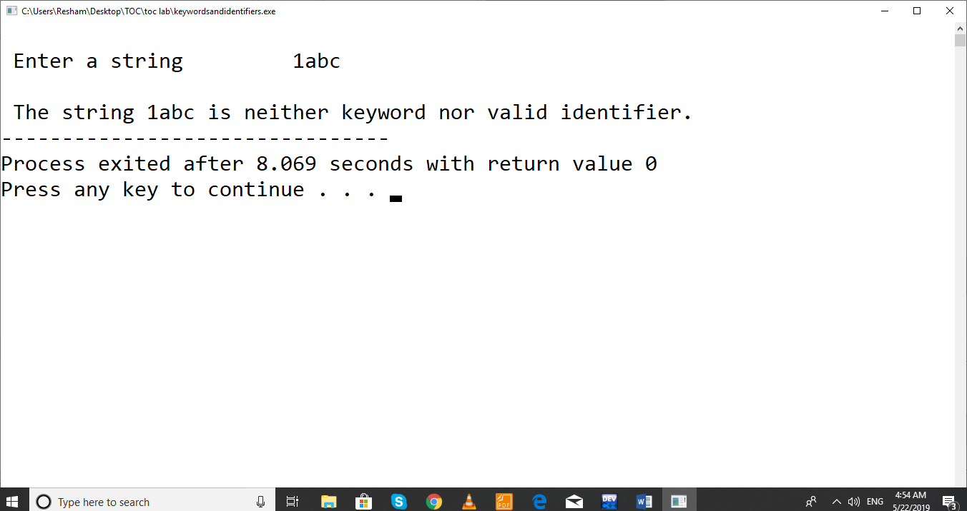

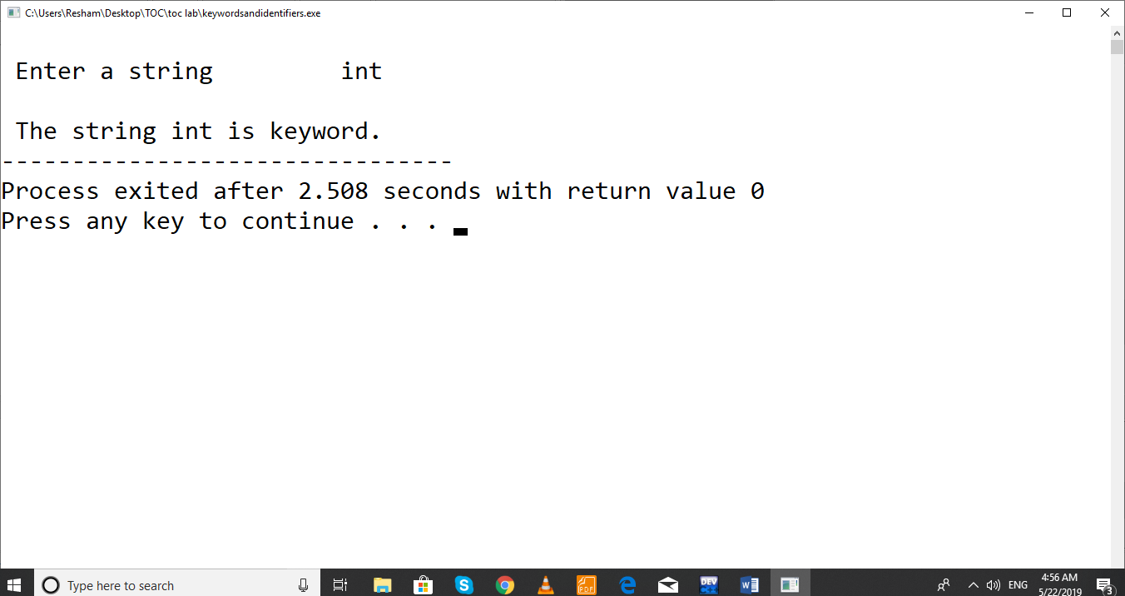

**LAB 4: Write a program to implement PDA that accepts all strings over alphabet $Σ=\{0,1\}$ that have equal number of 0s and 1s**

1. **by final state.**

Description of PDA:

It starts at q0 and pushes $ into the empty stack and switches to new state q1. At q1, PDA pushes input symbol if stack top symbol is $ or stack top is same as input symbol, otherwise if input is 0 and stack top is 1 or input is 1 and stack top is 0, stack top is popped off. If input is finished and stack top is $ at state q1, PDA switches to final state, qf. The figure for the PDA is given below.



Fig. PDA accepting equal number of 0s and 1s by final state

**Code for PDA accepting by Final State**

/* TOC Lab : Implement a PDA for L = { set of all strings over {0,1} such that equal number of 0s and 1s , acceptance by final state */

#include<stdio.h>

#include<string.h>

#define MAX 100

enum states { q0, q1,qf};

void push(char ch);

void pop();

char get_stack_top();

enum states delta(enum states, char, char);

struct stack

{

char symbols[MAX];

int top;

};

struct stack s;

int main()

{

char input[20];

enum states curr_state = q0;

s.top = -1;

int i =0;

char ch = 'e'; // e indicating epsilon

char st_top = 'e';

curr_state = delta(curr_state,ch,st_top);

printf("\n Enter a binary string\t");

gets(input);

ch = input[i];

st_top = get_stack_top();

int c=0;

while( c <=strlen(input))

{

curr_state = delta(curr_state,ch,st_top);

ch = input[++i];

st_top=get_stack_top();

c++;

}

if(curr_state == qf)

printf("\n The string %s is accepted.",input);

else

printf("\n The string %s is not accepted.",input);

return 0;

}

enum states delta(enum states s, char ch, char st_top)

{

enum states curr_state;

switch(s)

{

case q0:

if(ch=='e' && st_top=='e')

{

curr_state = q1;

push('$'); // $ is stack bottom marker

}

break;

case q1:

if(ch=='0' && (st_top=='$' ||st_top=='0'))

{

curr_state = q1;

push(ch);

}

else if(ch=='1' && (st_top=='$'||st_top=='1'))

{

curr_state = q1;

push(ch);

}

else if(ch=='1' && st_top=='0'||ch=='0'&&st_top=='1')

{

curr_state = q1;

pop();

}

else if(ch=='\0' && st_top=='$')

{

curr_state = qf;

pop();

}

break;

}

return curr_state;

}

//function to get stack top symbol

char get_stack_top()

{

return (s.symbols[s.top]);

}

//push function

void push(char ch)

{

if(s.top<MAX-1 )

{

s.symbols[++s.top] = ch;

}

else

{

printf("\n Stack Full.");

}

}

//pop function

void pop()

{

if(s.top>-1)

{

s.symbols[s.top]=' ';

s.top--;

}

else

printf("\n Stack Empty.");

}

**OUTPUT:**

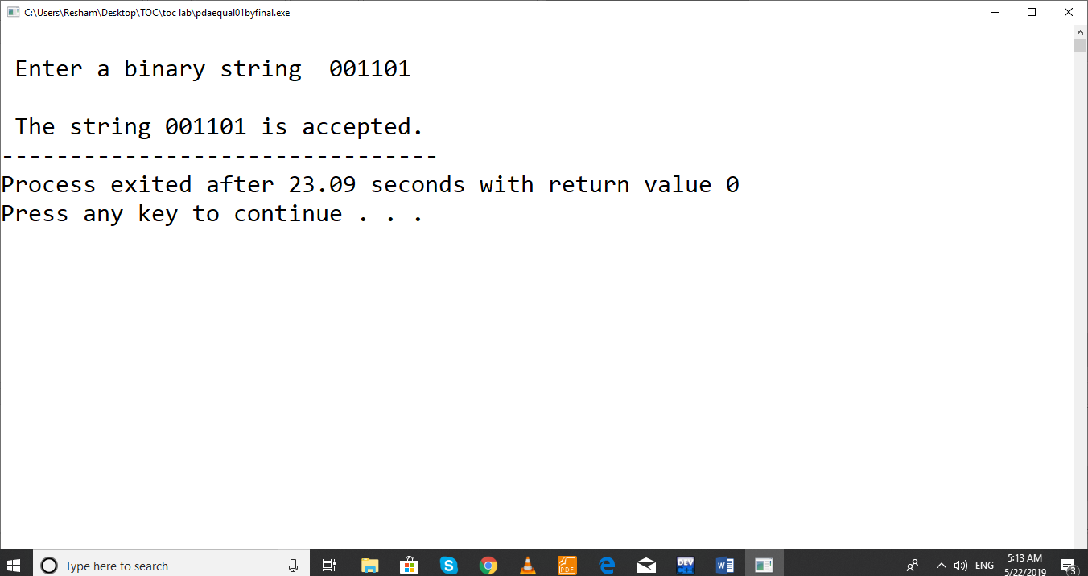

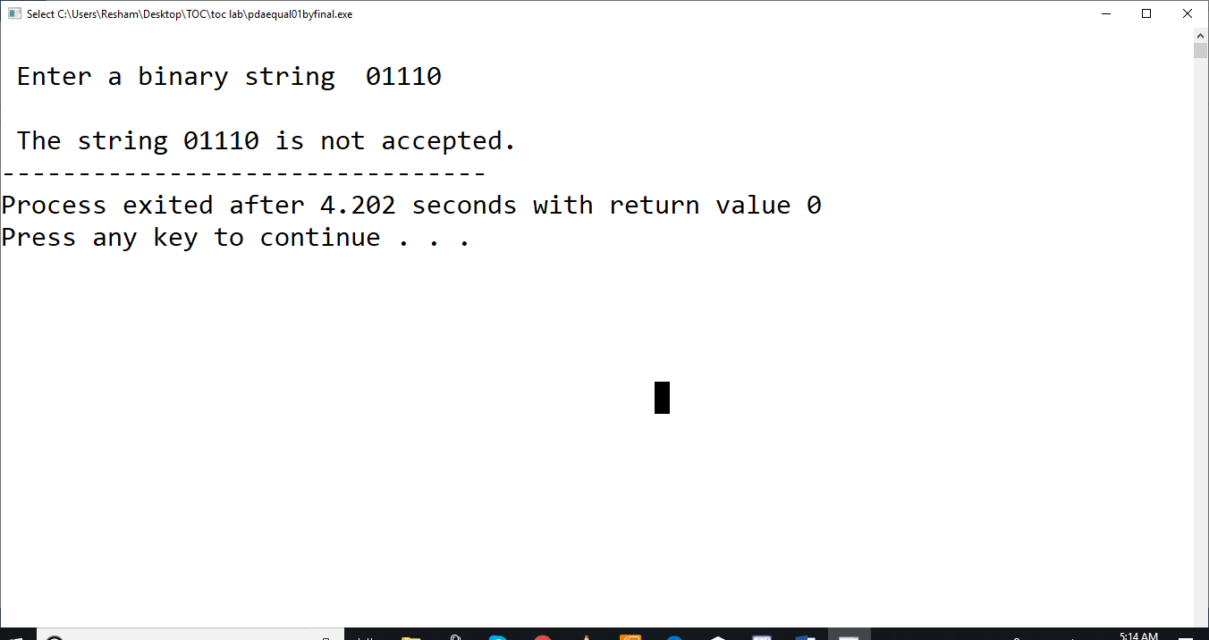

1. **PDA accepting equal number of 0s and 1s with empty stack**

**PDA description:**

It starts at q0 and pushes $ into the empty stack. At the same state q0, PDA pushes input symbol if stack top symbol is $ or stack top is same as input symbol, otherwise if input is 0 and stack top is 1 or input is 1 and stack top is 0, stack top is popped off. If input is finished and stack top is $, PDA accepts the input string. The figure for the PDA is given below.

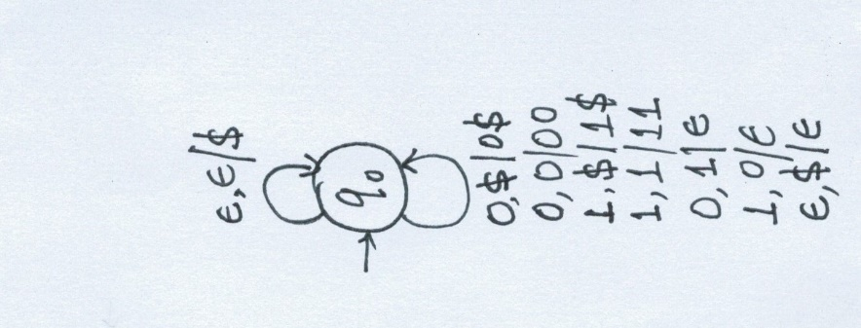

**Code for PDA Accepting by Empty Stack**

/* TOC Lab : Implement a PDA for L = { set of all strings over {0,1} such that equal number of 0s and 1s , acceptance by empty stack */

#include<stdio.h>

#include<string.h>

#define MAX 100

enum states { q0};

void push(char ch);

void pop();

char get_stack_top();

enum states delta(enum states, char, char);

struct stack

{

char symbols[MAX];

int top;

};

struct stack s;

int main()

{

char input[20];

enum states curr_state = q0;

s.top = -1;

int i =0;

char ch = 'e';

char st_top = 'e';

curr_state = delta(curr_state,ch,st_top);

printf("\n Enter a binary string\t");

gets(input);

ch = input[i];

st_top = get_stack_top();

int c=0;

while( c <=strlen(input))

{

curr_state = delta(curr_state,ch,st_top);

ch = input[++i];

st_top=get_stack_top();

c++;

}

if(s.symbols[s.top] == '$')

printf("\n The string %s is accepted.",input);

else

printf("\n The string %s is not accepted.",input);

return 0;

}

enum states delta(enum states s, char ch, char st_top)

{

enum states curr_state;

switch(s)

{

case q0:

if(ch=='e' && st_top=='e')

{

curr_state = q0;

push('$');

}

else if(ch=='0' && (st_top=='$' ||st_top=='0'))

{

curr_state = q0;

push(ch);

}

else if(ch=='1' && (st_top=='$'||st_top=='1'))

{

curr_state = q0;

push(ch);

}

else if(ch=='1' && st_top=='0'||ch=='0'&&st_top=='1')

{

curr_state = q0;

pop();

}

else if(ch=='\0' && st_top=='$')

{

curr_state = q0;

//pop();

}

break;

}

return curr_state;

}

char get_stack_top()

{

return (s.symbols[s.top]);

}

void push(char ch)

{

if(s.top<MAX-1 )

{

s.symbols[++s.top] = ch;

}

else

{

printf("\n Stack Full.");

}

}

void pop()

{

if(s.top>-1)

{

s.symbols[s.top]=' ';

s.top--;

}

else

printf("\n Stack Empty.");

}

**OUTPUT**

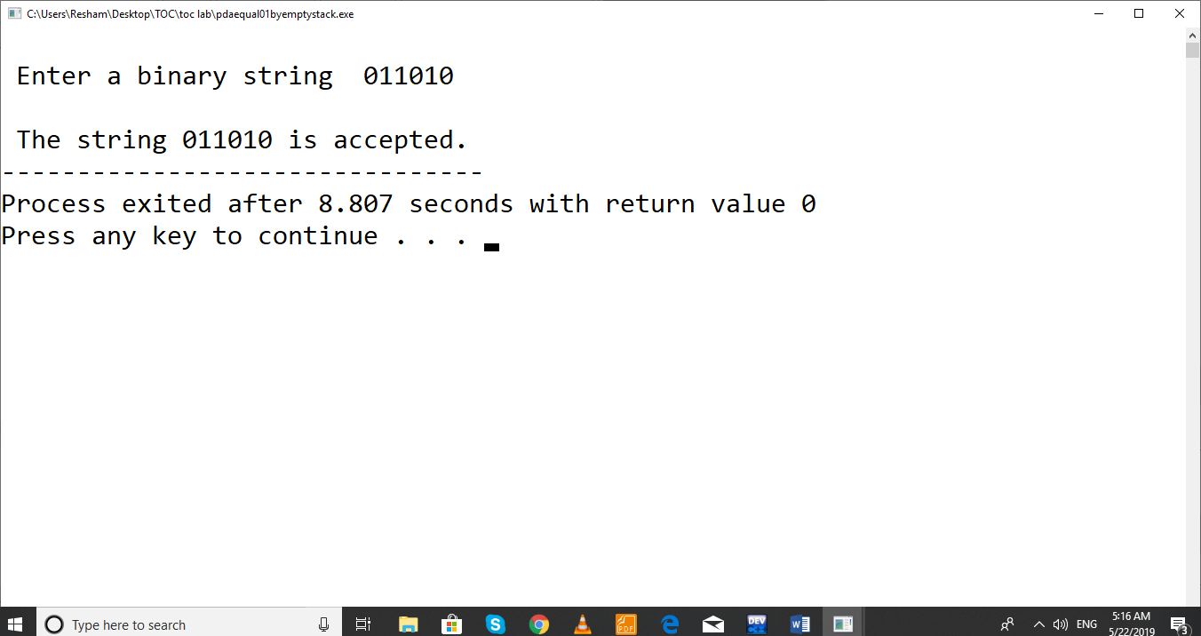

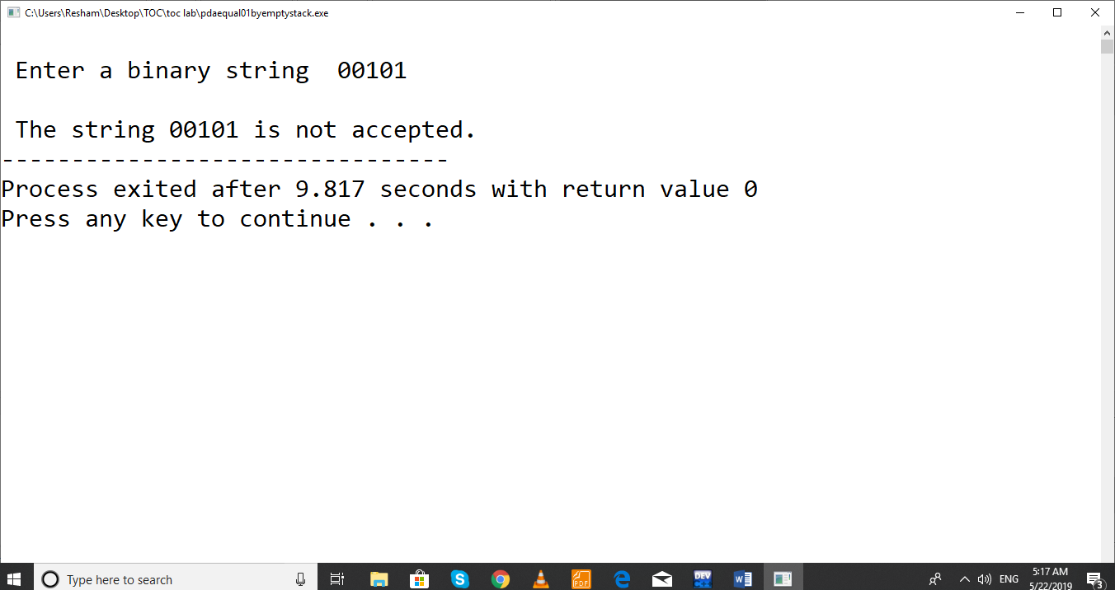

**LAB 5:**

Write a program to implement PDA that accepts all strings over alphabet $Σ=\{0,1\}$ that have contain number of 0's followed by equal number of 1s by final state.

**PDA Description:**

The PDA starts at q0 state. At this state, it simply pushes $ into the empty stack and switches to next state q1. At state q1, PDA pushes input 0 seen on the top of $ or 0 on the stack and if it sees 1 when stack top is 0, it pops the stack top switching to next state q2. At q2, it pops 0's for each 1 seen on the input. If no input symbol is present and $ on the top of stack, PDA switches to final state qf.

**Code:**

/* TOC Lab : Implement a PDA for L = { set of all strings over {0,1} such that 0^n1^n, acceptance by final state */

#include<stdio.h>

#include<string.h>

#define MAX 100

enum states { q0, q1,q2,qf,qr};

void push(char ch);

void pop();

char get_stack_top();

enum states delta(enum states, char, char);

struct stack

{

char symbols[MAX];

int top;

};

struct stack s;

int main()

{

char input[20];

enum states curr_state = q0;

s.top = -1;

int i =0;

char ch = 'e';

char st_top = 'e';

curr_state = delta(curr_state,ch,st_top);

printf("\n Enter a binary string\t");

gets(input);

ch = input[i];

st_top = get_stack_top();

int c=0;

while( c <=strlen(input))

{

curr_state = delta(curr_state,ch,st_top);

ch = input[++i];

st_top=get_stack_top();

c++;

}

if(curr_state==qf)

printf("\n The string %s is accepted.",input);

else

printf("\n The string %s is not accepted.",input);

return 0;

}

enum states delta(enum states s, char ch, char st_top)

{

enum states curr_state = qr;

switch(s)

{

case q0:

if(ch=='e' && st_top=='e')

{

curr_state = q1;

push('$');

}

break;

case q1:

if(ch=='0' && (st_top=='$' ||st_top=='0'))

{

curr_state = q1;

push(ch);

}

else if(ch=='1' && st_top=='0')

{

curr_state = q2;

pop();

}

else

curr_state = qr; // qr for undefined transition

break;

case q2:

if(ch=='1' && st_top=='0')

{

curr_state = q2;

pop();

}

else if(ch=='\0' and st_top=='$')

{

curr_state = qf;

pop();

}

else

curr_state = qr;

break;

}

return curr_state;

}

char get_stack_top()

{

return (s.symbols[s.top]);

}

void push(char ch)

{

if(s.top<MAX-1 )

{

s.symbols[++s.top] = ch;

}

else

{

printf("\n Stack Full.");

}

}

void pop()

{

if(s.top>-1)

{

s.symbols[s.top]=' ';

s.top--;

}

else

printf("\n Stack Empty.");

}

**Output:**

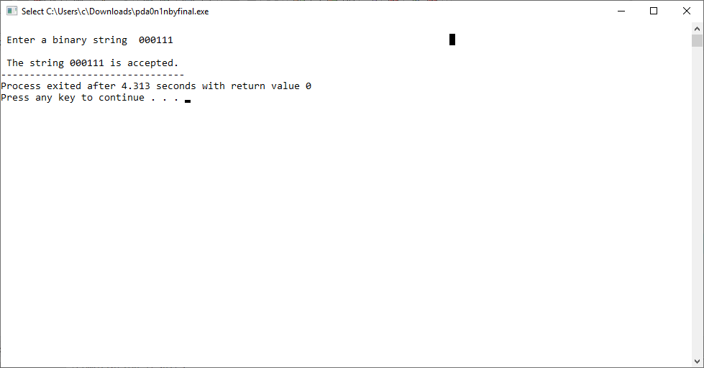

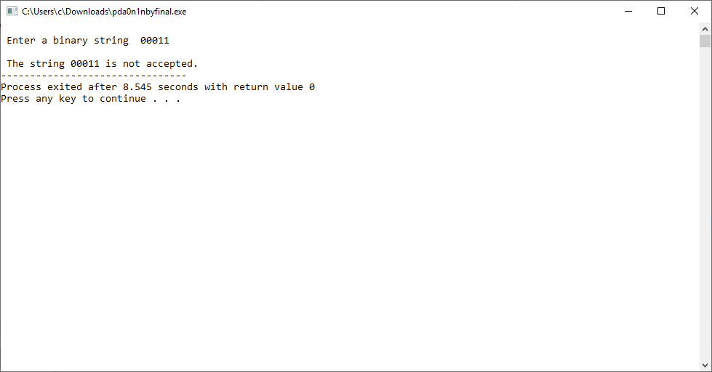

**Lab 6: Implement the TM accepting the language { 0n1n / n ≥ 1} over alphabet, $Σ=\{ 0,1\}$.**

**Turing Machine Description:**

Given finite sequence of 0’s and 1’s on tape and followed by blanks. The TM starts at state q0 and changes 0 to an X and moves to the right changing its state to q1.

At state q1, TM expects 1 and changes a 1 to Y and moves to the left changing the state to q2. If any number of 0s and Ys are seen, it remains on the state q1 and leaving these symbols unchanged and moving the head position to the right.

At state q2, if 0s or Y's are seen, it leaves them as it is and moves to the left staying at the same state q2. If it sees X at state q2, the tape symbol is left unchanged moves to right switching its state to q0.

At state q0, if it sees Y then the symbol is left unchanged and head is moved right changing to the state q3.

At state q3, if Y is seen, it is left unchanged and head is moved to the right. If BLANK (here, '\0') is seen at state q3, the string is accepted by switching the state to q4.

At any state, if the machine seen other than the defined symbols, it rejects the string.

The state transition diagram is shown in the figure below.

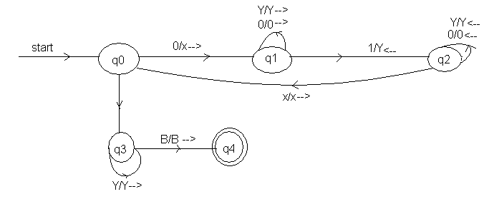

Y/Y-->

**Code:**

/* TOC Lab: Implement a TM for L = { set of all strings over {0,1} such that the string have number of 0s followed by same number of 1s. */

#include<stdio.h>

enum states { q0, q1, q2,q3,q4,qr};

int main()

{

char input[100];

enum states curr_state = q0;

int i;

for(i=0;i<100;i++)

input[i] = '\0';

printf("\n Enter a binary string\t");

gets(input);

i=0;

while(1)

{

switch(curr_state)

{

case q0:

if(input[i]=='0')

{

curr_state = q1;

input[i]='x';

i++;

}

else if(input[i]=='y')

{

curr_state=q3;

i++;

}

else

curr_state = qr; *// for invalid transition*

break;

case q1:

if(input[i]=='0')

{

curr_state = q1;

i++;

}

else if(input[i]=='y')

{

curr_state = q1;

i++;

}

else if(input[i]=='1')

{

curr_state = q2;

input[i]='y';

i--;

}

else

curr_state = qr;

break;

case q2:

if(input[i]=='0')

{

curr_state = q2;

i--;

}

else if(input[i]=='y')

{

curr_state = q2;

i--;

}

else if(input[i]=='x')

{

curr_state = q0;

i++;

}

else

curr_state = qr;

break;

case q3:

if(input[i]=='y')

{

curr_state = q3;

i++;

}

else if(input[i]=='\0')

{

curr_state=q4;

}

else

curr_state = qr;

break;

}*//end of switch*

if(curr_state == qr || curr_state==q4)

break;

}*//end of while loop*

if(curr_state == q4)

printf("\n The string is accepted.");

else

printf("\n The string is not accepted.");

return 0;

}

**OUTPUT**

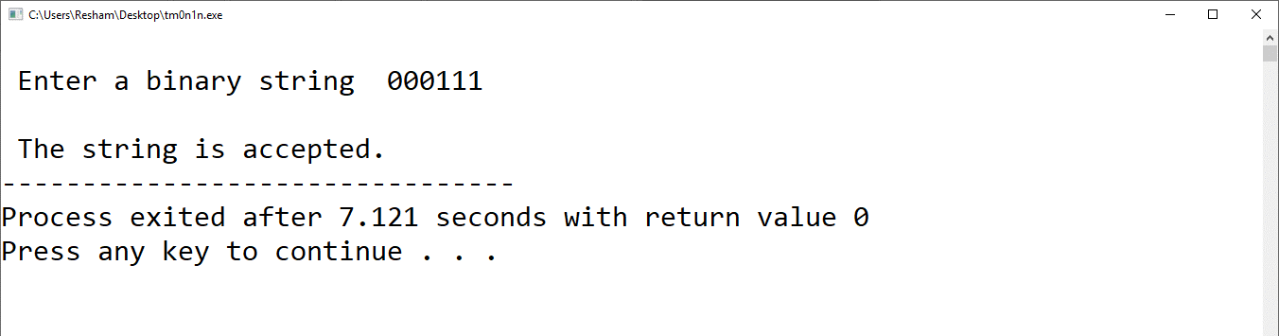

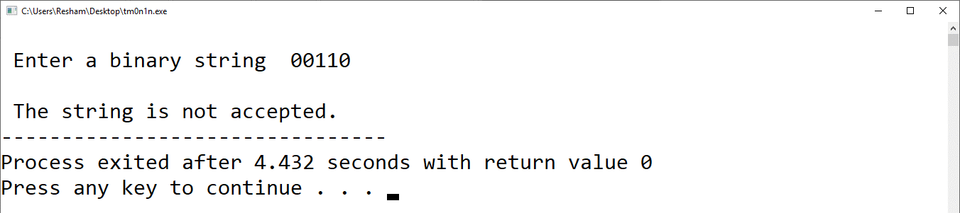

Q) Implement the TM: L={anbncn/ n>=0} by yourself…